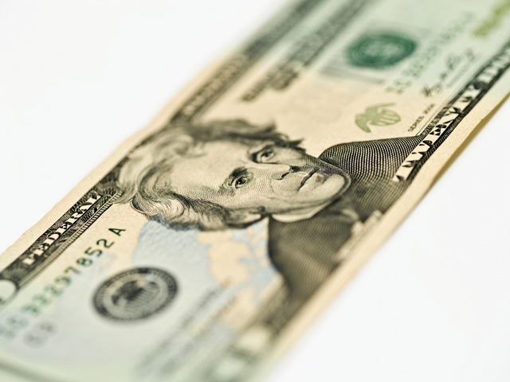
$10 Mary Kay Cash

Receive $10 Mary Kay Cash for each $50 you spend (at one time) with your consultant!!
$10 Mary Kay Cash

Receive $10 Mary Kay Cash for each $50 you spend (at one time) with your consultant!!
$10 Mary Kay Cash

Receive $10 Mary Kay Cash for each $50 you spend (at one time) with your consultant!!
$10 Mary Kay Cash

Receive $10 Mary Kay Cash for each $50 you spend (at one time) with your consultant!!
$10 Mary Kay Cash

Receive $10 Mary Kay Cash for each $50 you spend (at one time) with your consultant!!
10 Mary Kay Cash

Receive $10 Mary Kay Cash for each $50 you spend (at one time) with your consultant!!

